Topic : **2D Array**

1. A university offers 10 courses at each of three campuses. The number of students enrolled in each is presented in table below.

**Course**

**1 2 3 4 5 6 7 8 9 10**

**Campus**  **1** 5 15 22 21 12 25 16 11 17 23

**2** 11 23 51 25 32 35 32 52 25 21

**3** 2 12 32 32 25 26 29 12 15 11

Write a program to :

1. Find the total number of course enrollments on each campus.

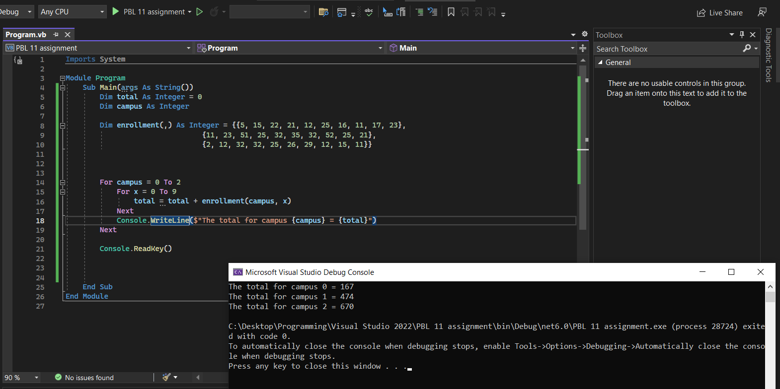

1. Find the total number of students taking each course.

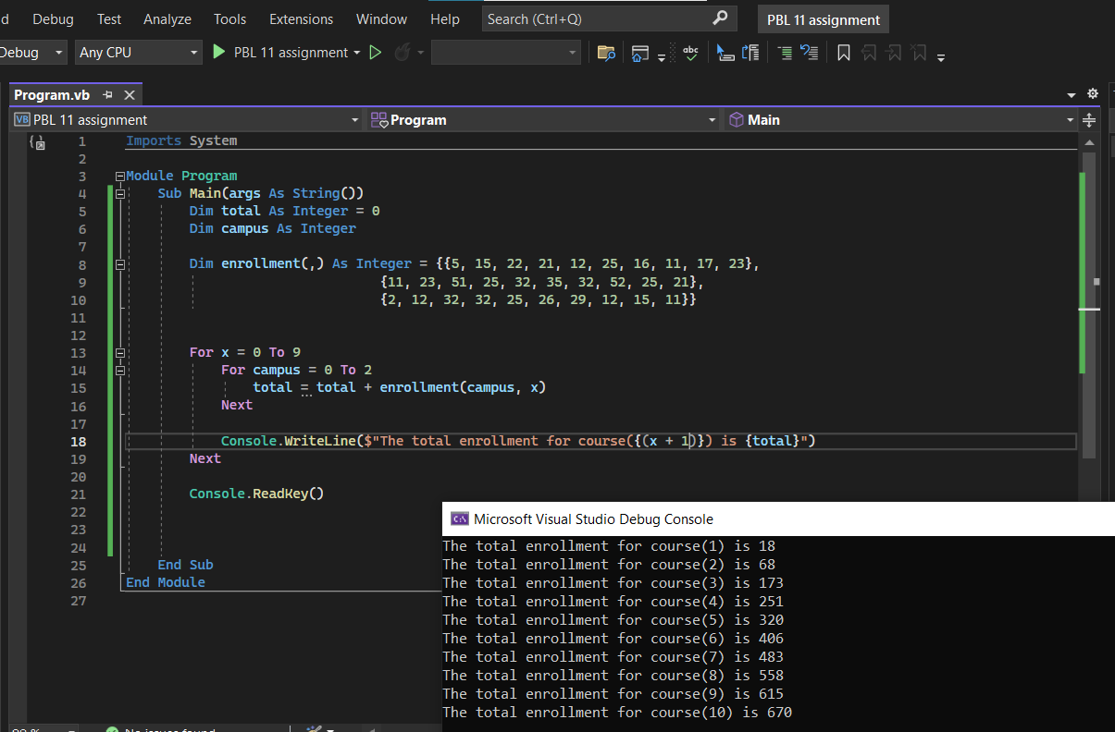

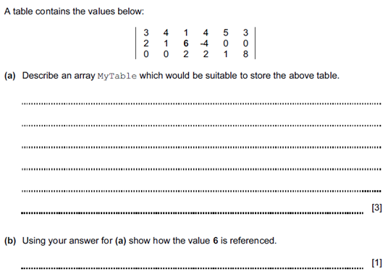2.

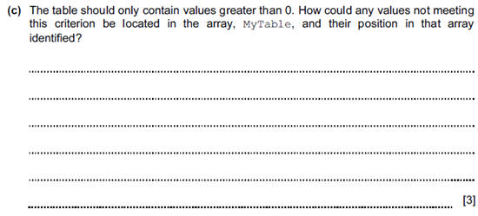

2

1. Dim MyTable(2, 5)
2. MyTable(1,2)
3. Use a For Next loop, the conditions of the for loop should be equal to the number of the rows and the columns, two for loops would be required for this to scan all values. Use an If statement inside the For loop and set the condition to (<= 0) so that values = 0 and lesser can be identified. Once identified remove the value from the table.